# Document Management Solution:

* **Solution based on** [**SharePoint Online**](https://www.microsoft.com/en-us/microsoft-365/sharepoint/collaboration) **which will allow your team to collaborate in a seamless manner with Zedra staff.**
* **As this solution is based on Microsoft SharePoint Online, you have the added benefit of extensive disaster recovery and security capabilities.**
* **Security options available which can be easily managed and customized per business requirements:**

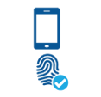

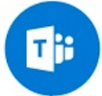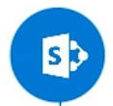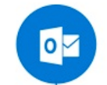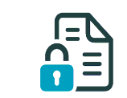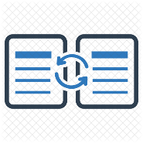

**Feature summary**:

* **Custom Landing page and company branding**
* **Access content from anywhere, including mobile device**
* **Upload and Share Documents with your team**
* **Ability to manage documents in a structured manner**

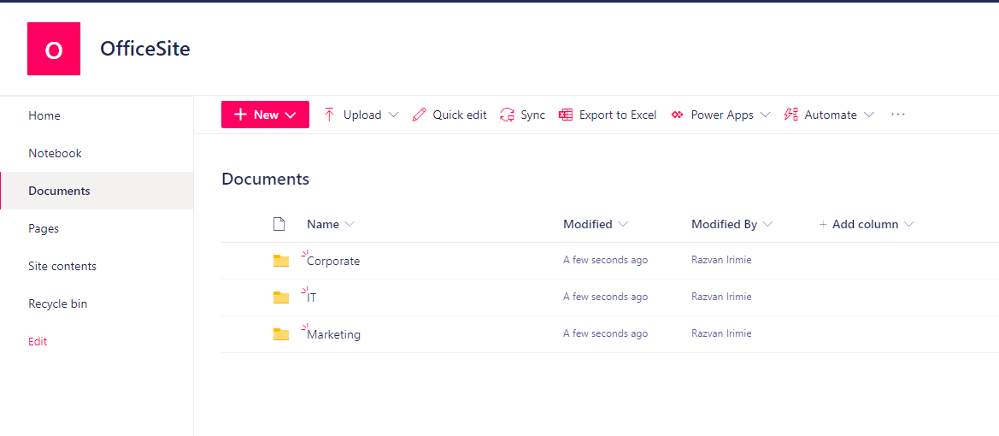**Intuitive and familiar user interface shared across all Microsoft Services**

* **Scalable storage options and disaster recovery options**
* **Ability to view and manage storage metrics**

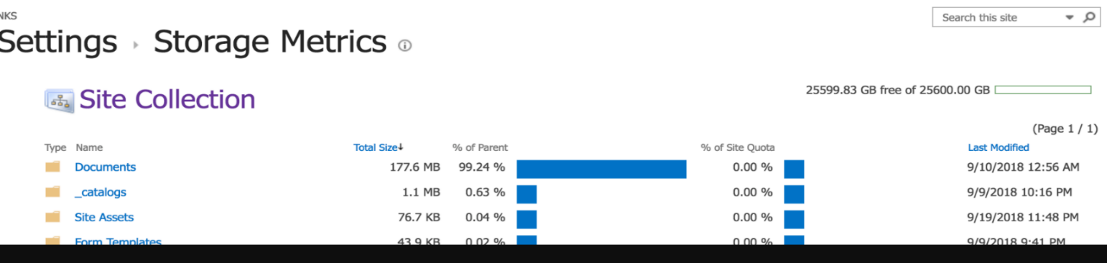

* **Integration with Microsoft 365 Services**

